- Production tonnage/hr (in tones).
400-600ton/h is a good generic reference.
- Output size of cutting .
Less than 10cm.
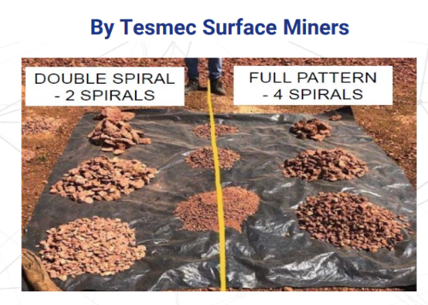
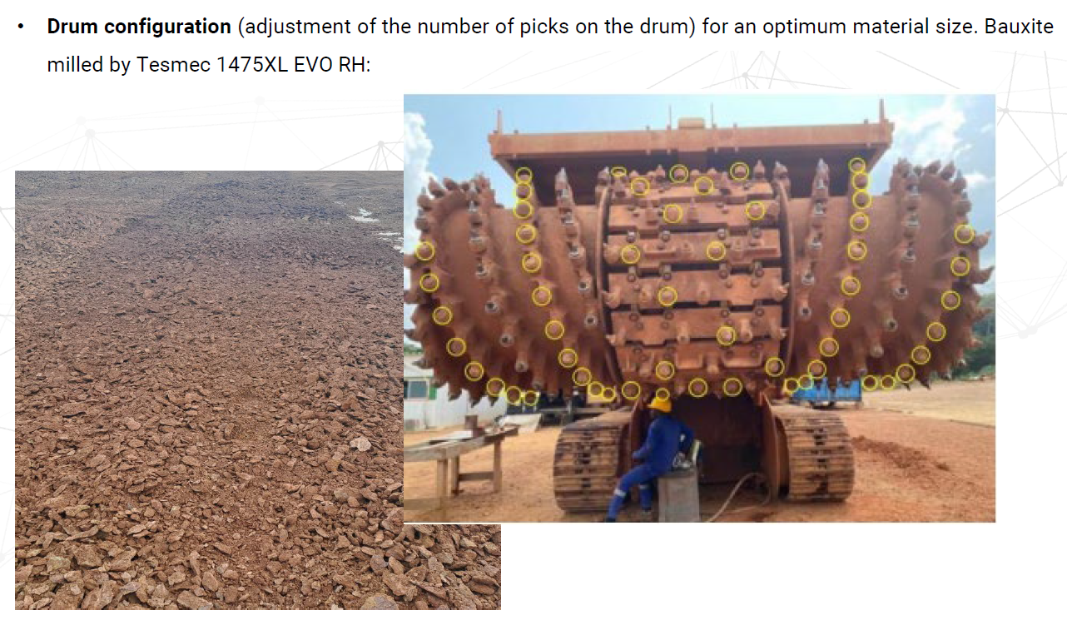
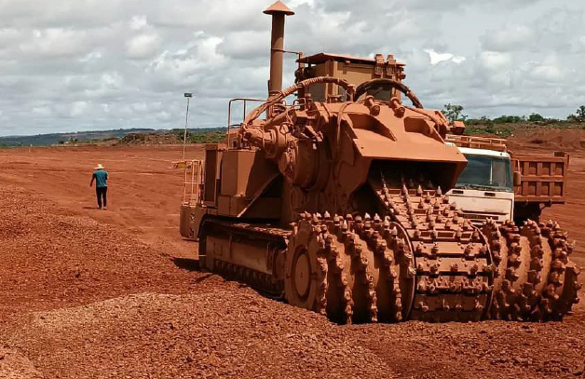
- Total quantity required is 10-15nos in a year.
Depends on productivity. If target is 2MT per year, then three units maybe be enough (1 backup included).
- Kindly share best discounted prices.
To be checked.
- Price basis- FOB or FCA.
To be checked.
- Payment terms :- Supplier to confirm.
Standards:
30% at time of receipt of PO payable at sight against invoice.
70% payable at sight before collection EXW of the machine Delivery lead time supplier to confirm.
Credit letters also can be accepted.
Please share your desired payment terms.
- 02 year recommended spare part list with pricing & lead time.
2 year recommended spare parts will be sent in container. Tesmec Guinee subsidiary will support aswell.
Lead time to be checked.

- FOC spare part list.
Yes and mainly consist of:
One base spare parts kit (n°1 Engine filters cartridges kit (oil, diesel fuel, etc) - n°1 Engine air filters kit
(primary + safety cartridges) - n°1 Hydraulic filters cartridges kit - n°1 A/C cartridges kit (dryer filter and pressurizer) - Fuses - Air breathers - n°1 Structural welding electrodes - n°1 Hard surfacing electrode).
Digging blocks, Extra digging teeth provided in Tesmec boxes and Digging group hardware (bolts and nuts).

OPM (Overall part manufacturer) list.
Engine Caterpillar.
Pumps/Valves and electronics Danfoss.
Motors Bosch.
Gearboxes Tesmec/Bonfiglioli.
- Guaranty/warranty.
Machine:
Standard for machine is 1 year or 1000h.
- Option 1: is 2 years or 2000h at 50k.
- Option 2: is 3 years or 3000h at 100k.
Engine:
Standard is 4 years or 6000 h.

